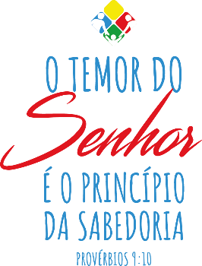
O temor do Senhor é o princípio da sabedoria.
Provérbios 9:10

3º. ANO – MANHÃ
1. READ:

In my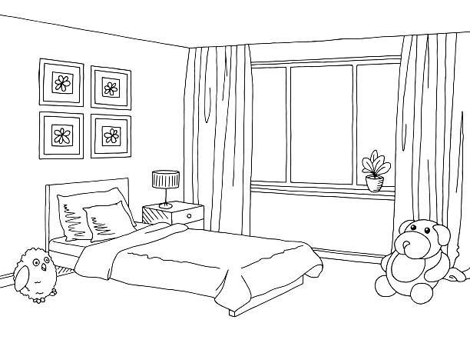 , there is a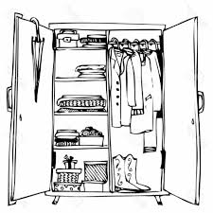,
a 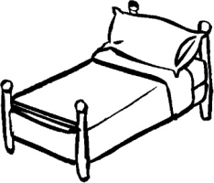, a 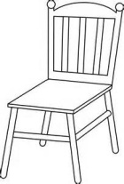 and a nice 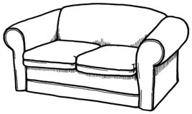.
I love my bedroom! It´s my favorite place in the .

2. REWRITE THE TEXT USING THE CORRECT WORDS:
_______________________________________________________________
_____________________________________________________
_____________________________________________________
_____________________________________________________
_____________________________________________________

